Indexes
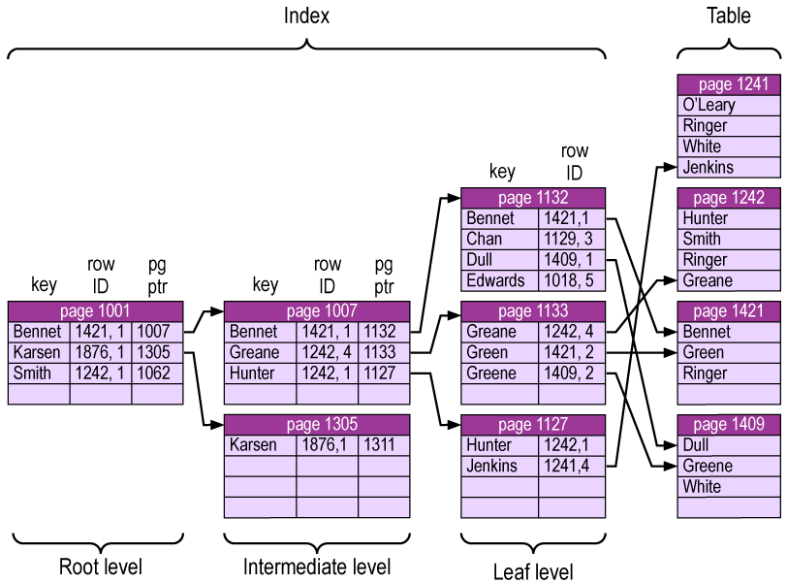

--table scan is a scan that reads every row in a table
--table that does not have any indexes created on it can be searched only via a table scan
---------------
--table can have on clustered index
--table can have up to 249
--indexes---
--table scan is a scan that reads every row in a table
--table that does not have any indexes created on it can be searched only via a table scan
----------------------------------------------------------------------------
create table stud
(
id int primary key,
sname nvarchar(50),
sal int,
age int
)
--indexing affect with the existing data
insert into stud(id) values (2)
insert into stud(id) values (1)

insert into stud(id,sal) values (3,100)
insert into stud(id,sal) values (5,50)

select * from stud

create clustered index cindex
on stud(sal)

create nonclustered index cindex
on stud(sal)

create unique index uni_index
on stud(sal)

drop index stud.uni_index
---------------
--table can have on clustered index
--table can have up to 249
use ITI
--1)unique index
create unique index uni_index
on student(st_fname)

drop index student.non_uni_index
---unique nonclustered noncomposite

--2)non unique index

create index non_uni_index
on student(st_fname)

--3)clustured index
create clustered index clus_ind --nonclustered
on department(Dept_Manager)

--5)composite index
--6)non composite attribute

-----------------------------------------------------------------------------
--the TerminationReason table was created without a primary key defined,
--meaning that initially, the table was a “heap.”
--The primary key was then added afterward using ALTER TABLE.
--The word CLUSTERED follows the PRIMARY KEY statement,
--thus designating a clustered index with the new constraint
USE AdventureWorks
GO
CREATE TABLE HumanResources.TerminationReason(
TerminationReasonID smallint IDENTITY(1,1) NOT NULL,
TerminationReason varchar(50) NOT NULL,
DepartmentID smallint NOT NULL,
CONSTRAINT FK_TerminationReason_DepartmentID
FOREIGN KEY (DepartmentID) REFERENCES
HumanResources.Department(DepartmentID)
)
---create pk
ALTER TABLE HumanResources.TerminationReason
ADD CONSTRAINT PK_TerminationReason
PRIMARY KEY CLUSTERED (TerminationReasonID)
---------
CREATE CLUSTERED INDEX CI_TerminationReason_TerminationReasonID ON
HumanResources.TerminationReason (TerminationReasonID)
---------------------------
CREATE NONCLUSTERED INDEX NCI_TerminationReason_DepartmentID ON
HumanResources.TerminationReason (DepartmentID)

